**DETAILED DESCRIPTION OF E-COMMERCE PROJECT**

**Topic Name: “*Back-end view of an E-Commerce website”***

***Kashish Chopra***

***5152018***

It was critical that the backend be easy for the site administrator or staff to use and that it minimize data entry errors so the catalogue and order form could access information correctly and consistently. Besides the image uploader, who ensures that product images are named correctly and stored on the server in the expected location, it includes other error checking. For example, if a product does not have pricing information, it automatically makes that product inactive, hiding it from customers until the store is ready to begin selling it. Products with add-on items (such as RSVP cards for invitations) show the add-on items when editing the primary product, making it immediately apparent if anything is missing, and letting you edit pricing for all related products at the same time you edit the primary product. If a product requires the customer to upload digital images, the admin is prompted to enter the number of images and size for each. This is used on both the catalogue pages (letting the customer know they will need to provide images) and the order form, which allows a customer to upload as many images as the product needs.

Since the new catalogue template generates meta-data from the product information, it seemed like a good idea to show that on the product editing screen, so descriptions could be written with SEO in mind. Therefore, the admin not only has a link they can use to see exactly what the customer will see, but also information showing them exactly what will be generated for the title, description and keywords a search engine sees.

Back-end Features of a Successful Ecommerce Website

* Dashboard. As the administrator of your website, you should have a place where you can review all pertinent information regarding your the performance of your website. The dashboard should be customizable and offer summary information regarding various aspects of the website: out of stock items, information requests, sales figures, and ecommerce performance metrics.
* Administrator Management. You may have a team to work on your website, which means you should be able to give each team member a certain amount of administrative control. You should be able to decide what sections of your CMS each team member can edit or view.
* META Data Control. Ability to control your meta data is crucial when trying to get your website to rank well for various relevant keywords in search engines. You should be able to customize the title tag of every page on your website as well as easily create rules for types of pages to handle title tag creation. For example, you would not want to have to write the page title of each and every product on your website, especially if you have thousands of products. Instead, creating rules for each product will help you optimize a large number of product pages all at once.
* Crawler Control. A robots.txt file allows you to limit what content search engine crawlers get access to. Your content management system should allow you to upload a robots.txt and also be able to edit it if need be.
* Sitemap. A sitemap.xml file tells search engines of all the pages on your website, to ensure that those pages get crawled.
* Tracking Code Addition and Editing. Whether it’s your Google Analytics code or Google Website Optimizer, you should have the ability to easily add and update tracking code on various pages. This will compress testing timelines by skipping the need for a web developer each time work is required.
* Store Management. Each of your categories, subcategories, and products should be easily editable through your ecommerce back-end. That includes updating of product colors, sizes, descriptions, etc. and the ability to specify which product to feature on the home page.
* Order Management. Whether you have integrated with a 3rd party system or not, you should have a comprehensive understanding of the status of sales on the website, shipping orders, and customer information.

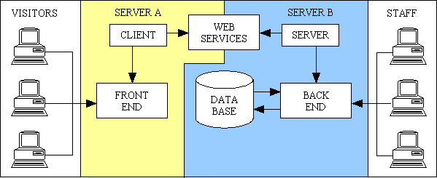

**3-Tier Architecture diagram.**